For SSM /MBRS server login VM remote

IP : 10.222.24.74 / 10.222.24.73
User: devuser
Pwd: devuser123

From: Hans Brian
Sent: Wednesday, August 30, 2017 4:19 PM
To: Madhu Sudhana Rao; Matthew Oh
Cc: OIL Infra Team; Mohd Anas Bin Ahmad; Jason Lim Jia Xheng
Subject: SSM Dev servers

Hi Madhu and Matt,

We have created 3 SSM development servers as per below:

http://ssmdevrpt.southeastasia.cloudapp.azure.com/SSMReporting/ReportManager
http://ssmdevpoc.southeastasia.cloudapp.azure.com/SSMROB/Application/New

- Application server (ssmdev)
ssmdev 52.187.108.76
ssmdev-IIS-SQL 52.148.85.43
SSMReporting 52.230.65.155
DNS: ssmdevrpt.southeastasia.cloudapp.azure.com
ssmdev.southeastasia.cloudapp.azure.com
RDP Information (RDP File attached)
Username: dbadmin
Password: gb7FMX$y_v

SSM VPN
Username: amirafizul
Password: SSM@user123

10.220.25.85
CMLDBDVVPDC2301
ssmdb/ ssmmigdb

10.220.25.86 --- Foster Moore DB
CFMDBVVPDC2301
ssmdb/ ssmmigdb

- Oracle (ssm-rob-db01)
Public IP address: 104.215.186.11
DNS: ssmrobdb01.southeastasia.cloudapp.azure.com

Oracle SQL Developer
Connection name : ssmrobdb
Username: system
Password: C6QT2IGl{p31

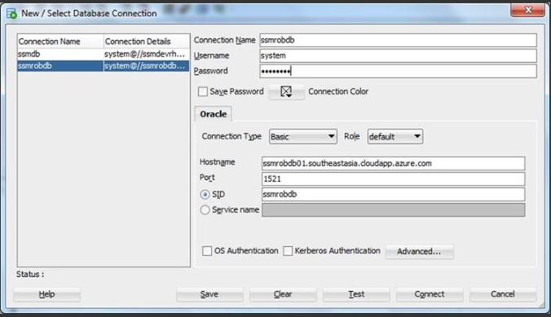

Oracle web page
https://104.215.186.11:5500/em/login
Username: sys
Password: Passw0rd
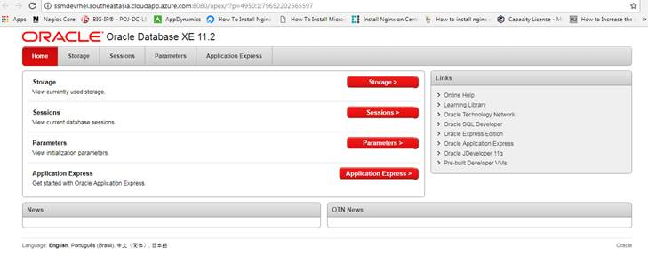
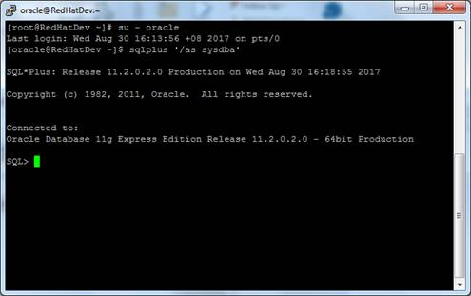

SQLPLUS (ssm-rob-db01)
Username: oracle
Password: ajnTYegrU+YzH7k

Linked Server
//ssmdevrhel2.southeastasia.cloudapp.azure.com:1521/ssmdb

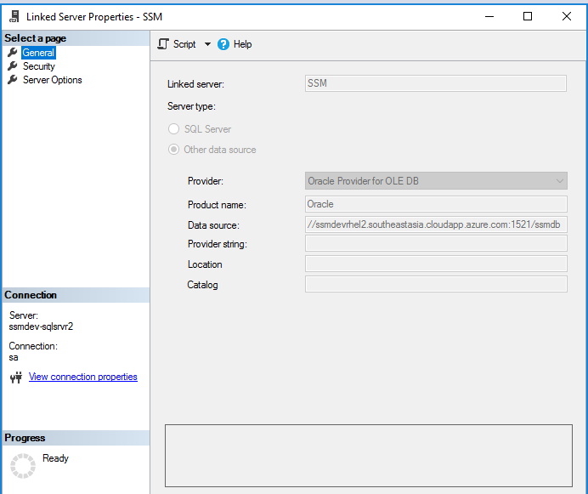

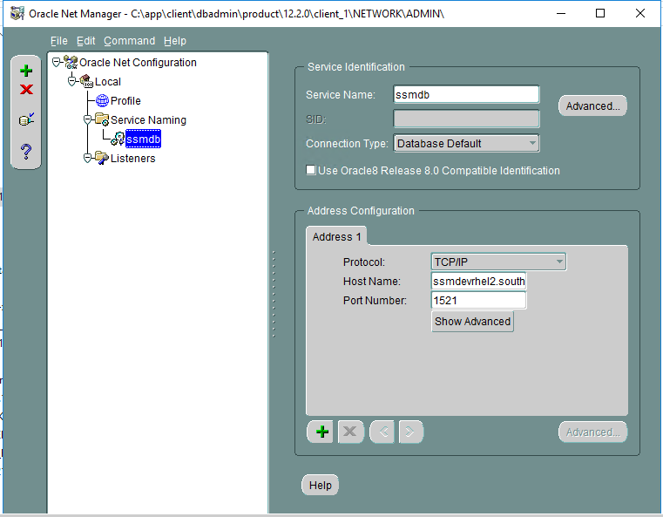
Ssmdb
ssmdevrhel2.southeastasia.cloudapp.azure.com
1521

Please let me know if any other information is required.

Thank you
Regards,
Hans Brian

